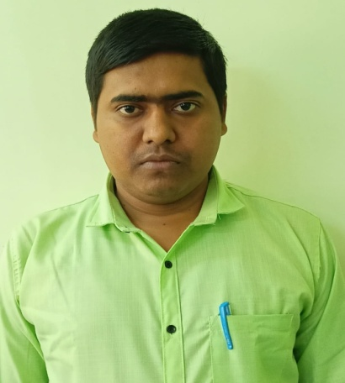**Format of Curriculum vitae (CV)**

Name: ARABINDA DEY

Designation: Assistant Professor

Institution Name: Kharagpur College

Department: Philosophy

Mobile No: 8972017030

Email Address: arabinda2018dey@gmail.com

Qualification: M.A., M.Phil.

Teaching Experience: 2 years

Research Experience and Area: Pursing Doctorial research work , Research area: The Concept of Substance from Western Perspective.

Publications in International Journals: NA

inNational (UGC Listed) Journals: NA

Chapter in books Published: 02

Development of e-learning study module: NA

Presented Paper in Seminar: “Sambidhan Anumodita Samrakhan Byabosthar Parjalochona”, National Seminar, **Organised by-** Vidyasagar University Philosophy Alumni Association.

Delivered Invited Lecture: Yes

Research Projects: NA

Research Guidance: NA

Fellowship/Award/recognition received: NA

Editor or Reviewer of a Journal: NA

Organized Workshop: NA

Administrative responsibility: NSS Programme Officer

Participation in Board of Studies: NA

Members in different Committee: NA

Contribution to Professional Bodies: NA

Any other: